# Visionary leader

|  |
| --- |
|  |
| **Ratan Naval Tata** |
| [https://upload.wikimedia.org/wikipedia/commons/thumb/6/6b/Ratan_Tata_2011_%28The_TCS_Story_Launch_-_CII%29_%28cropped%29.jpg/220px-Ratan_Tata_2011_%28The_TCS_Story_Launch_-_CII%29_%28cropped%29.jpg](https://en.wikipedia.org/wiki/File:Ratan_Tata_2011_(The_TCS_Story_Launch_-_CII)_(cropped).jpg) |

Biography

## ratan naval tata was the son of [naval tata](https://en.wikipedia.org/wiki/Naval_Tata), who was adopted by [ratanji tata](https://en.wikipedia.org/wiki/Ratanji_Tata), son of [jamshedji tata](https://en.wikipedia.org/wiki/Jamshedji_Tata), the founder of the [tata group](https://en.wikipedia.org/wiki/Tata_Group). he graduated from [cornell university college of architecture](https://en.wikipedia.org/wiki/Cornell_University_College_of_Architecture,_Art,_and_Planning) with a bachelor's degree in architecture. he was an indian industrialist and philanthropist. he served as the chairman of [tata group](https://en.wikipedia.org/wiki/Tata_Group) and [tata sons](https://en.wikipedia.org/wiki/Tata_Sons) from 1991 to 2012 and he held the position of interim chairman from october 2016 to february 2017. in 2000, he received the [padma bhushan](https://en.wikipedia.org/wiki/Padma_Bhushan), the third highest civilian honour in india, followed by the [padma vibhushan](https://en.wikipedia.org/wiki/Padma_Vibhushan), the country's second highest civilian honour, in 2008.

## **Early life and education**

*Main article:*[*Tata family*](https://en.wikipedia.org/wiki/Tata_family)

Ratan Tata was born in Bombay (now [Mumbai](https://en.wikipedia.org/wiki/Mumbai)), during the [British Raj](https://en.wikipedia.org/wiki/British_Raj), into a [Parsi](https://en.wikipedia.org/wiki/Parsis) [Zoroastrian](https://en.wikipedia.org/wiki/Zoroastrianism) family, on 28 December 1937. He was the son of [Naval Tata](https://en.wikipedia.org/wiki/Naval_Tata) (who was born in [Surat](https://en.wikipedia.org/wiki/Surat) and later adopted into the Tata family), and Soonoo Tata (the niece of Tata group founder [Jamsetji Tata](https://en.wikipedia.org/wiki/Jamshedji_Tata)). Tata's biological grandfather, Hormusji Tata was a member of the Tata family by blood. In 1948, when Tata was 10, his parents separated, and he was subsequently raised and adopted by Navajbai Tata, his grandmother and widow of Ratanji Tata. He had a younger brother Jimmy Tataand a half-brother, [Noel Tata](https://en.wikipedia.org/wiki/Noel_Tata), from Naval Tata's second marriage to his stepmother [Simone Tata](https://en.wikipedia.org/wiki/Simone_Tata).

Tata studied at the [Campion School, Mumbai](https://en.wikipedia.org/wiki/Campion_School,_Mumbai) until 8th grade. He then continued his studies at the [Cathedral and John Connon School](https://en.wikipedia.org/wiki/Cathedral_and_John_Connon_School) in [Mumbai](https://en.wikipedia.org/wiki/Mumbai), the [Bishop Cotton School](https://en.wikipedia.org/wiki/Bishop_Cotton_School_(Shimla)) in [Shimla](https://en.wikipedia.org/wiki/Shimla), and the [Riverdale Country School](https://en.wikipedia.org/wiki/Riverdale_Country_School) in New York City, from which he graduated in 1955. After high school, Tata enrolled in [Cornell University](https://en.wikipedia.org/wiki/Cornell_University), from which he graduated with a bachelor's degree in architecture in 1962. While at Cornell, Tata became a member of the [Alpha Sigma Phi Fraternity](https://en.wikipedia.org/wiki/Alpha_Sigma_Phi). In 2008, Tata gifted Cornell $50 million, becoming the largest international donor in the university's history

Career

Early years

In 1961 Tata met architect [A. Quincy Jones](https://en.wikipedia.org/wiki/A._Quincy_Jones) who spent three weeks as architecture design critic at Cornell. After completing Cornell, Tata briefly joined Jones at his firm Jones & Emmons in Los Angeles. While Tata was planning to settle in Los Angeles, he was called back to India by his grandmother.

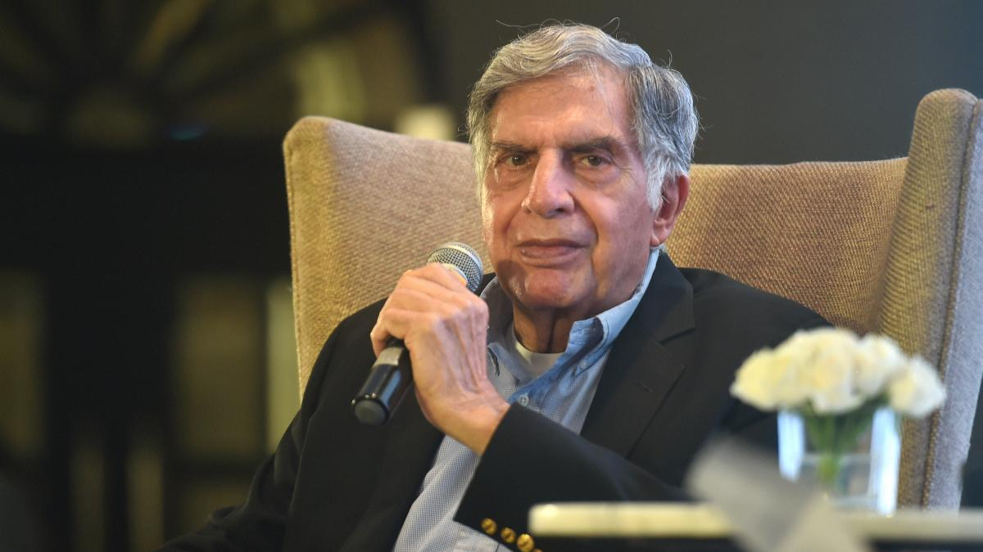

Later years

In the 1970s, Ratan Tata was given a managerial position in the Tata group. He achieved initial success by turning the subsidiary National Radio and Electronics (NELCO) around, only to see it collapse during an economic slowdown. In 1991, [J. R. D. Tata](https://en.wikipedia.org/wiki/J._R._D._Tata) stepped down as chairman of Tata Sons, naming him his successor. Initially, Tata faced stiff resistance from the heads of various subsidiaries, who had a large amount of operational freedom under the senior Tata's tenure. In response, Tata implemented a number of policies designed to consolidate power, including the implementation of a retirement age, having subsidiaries report directly to the group office, and requiring subsidiaries to contribute their profit to building the Tata group brand. Tata prioritised innovation and delegated many responsibilities to younger talent. Under his leadership, overlapping operations between subsidiaries were streamlined into company-wide operations, with the group exiting unrelated businesses to take on globalisation.

Ratan meets union minister [Anand Sharma](https://en.wikipedia.org/wiki/Anand_Sharma) in 2011

During the 21 years Tata led the Tata Group, revenue grew over 40 times, and profit over 50 times. When he took over the company, sales overwhelmingly comprised commodity sales, but at the end of his tenure, the majority of sales came from brands. He had [Tata Tea](https://en.wikipedia.org/wiki/Tata_Global_Beverages) acquire [Tetley](https://en.wikipedia.org/wiki/Tetley), [Tata Motors](https://en.wikipedia.org/wiki/Tata_Motors) acquire [Jaguar Land Rover](https://en.wikipedia.org/wiki/Jaguar_Land_Rover), and [Tata Steel](https://en.wikipedia.org/wiki/Tata_Steel) acquire [Corus](https://en.wikipedia.org/wiki/Corus_Group_plc). These acquisitions repositioned Tata from a largely India-centric group into a global business, with over 65% of revenues coming from operations and sales internationally.

He also conceptualised and spearheaded the development of the [Tata Nano](https://en.wikipedia.org/wiki/Tata_Nano) car after the grand success of Diesel [Tata Indica](https://en.wikipedia.org/wiki/Tata_Indica), which helped put cars at a price-point within reach of the average Indian consumer. [Tata Motors](https://en.wikipedia.org/wiki/Tata_Motors) has since rolled out the first batch of Tigor Electric Vehicles from its [Sanand Plant](https://en.wikipedia.org/wiki/Sanand_Plant_(Tata_Motors)) in Gujarat, which Tata has described as to "fast-forward India's electric

Tata supported [University of New South Wales](https://en.wikipedia.org/wiki/University_of_New_South_Wales) [Faculty of Engineering](https://en.wikipedia.org/wiki/UNSW_Faculty_of_Engineering) to develop capacitive deionisation to provide improved water for challenged areas.

University of California

[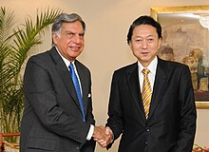](https://en.wikipedia.org/wiki/File:28india1.jpg)

Ratan with a Japan delegate.Tata Hall at the [University of California, San Diego](https://en.wikipedia.org/wiki/University_of_California,_San_Diego) (UC San Diego) is a state-of-the-art research facility that was opened in November 2018. The building is named after the [Tata Trusts](https://en.wikipedia.org/wiki/Tata_Trusts), who donated $70 million to UC San Diego in 2016 to establish the Tata Institute for Genetics and Society (TIGS), which is housed within the building. The Tata Institute for Genetics and Society at UC San Diego is a joint initiative between the Tata Trusts and UC San Diego. It aims to address some of the world's most pressing problems, such as the spread of infectious diseases and the need for sustainable food sources. The research conducted at the institute focuses on a range of topics, including gene editing, stem cell therapy, and disease control.[]](https://en.wikipedia.org/wiki/Ratan_Tata#cite_note-:1-54) Tata Hall at the UC San Diego is a 4-storey building that is spread over 128,000 square feet and houses research facilities for the biological and physical sciences. The building has laboratories, offices, and meeting spaces that are designed to foster collaboration and innovation among researchers. It is a [LEED-certified](https://en.wikipedia.org/wiki/LEED) building; designed to be environmentally sustainable and energy-efficient.

## Board memberships and affiliations

[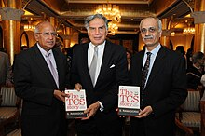](https://en.wikipedia.org/wiki/File:The_TCS_Story_Launch_-_CII.jpg)Ratan at TCS Story Launch .Ratan Tata was the [interim chairman](https://en.wikipedia.org/wiki/Interim) of [Tata Sons](https://en.wikipedia.org/wiki/Tata_Sons). He headed the main two Tata trusts [Sir Dorabji Tata and Allied Trusts](https://en.wikipedia.org/wiki/Sir_Dorabji_Tata_and_Allied_Trusts) and [Sir Ratan Tata Trust](https://en.wikipedia.org/wiki/Sir_Ratan_Tata_Trust) and their allied trusts, with a combined stake of 66% in Tata Sons, Tata group's holding company.

He served in various capacities in organisations in India and abroad. He was a member of Prime Minister's 'Council on Trade and Industry' and the 'National Manufacturing Competitiveness Council'. He was on the jury panel of [Pritzker Architecture Prize](https://en.wikipedia.org/wiki/Pritzker_Architecture_Prize)– considered to be one of the world's premier architecture prizes.

Over the years, Tata had served on the [Cornell University](https://en.wikipedia.org/wiki/Cornell_University) Board of Trustees, personally advising the school's administration in matters of international involvement, particularly regarding projects connected to India. More broadly, Tata had served on the board's Academic Affairs, Student Life, and Development Committees. In 2013 he was named Cornell Entrepreneur of the Year.

He was a director on the boards of [Alcoa](https://en.wikipedia.org/wiki/Alcoa) Inc., [Mondelez International](https://en.wikipedia.org/wiki/Mondelez_International) and Board of Governors of the [East–West Center](https://en.wikipedia.org/wiki/East%E2%80%93West_Center). He was also a member of the board of trustees of [University of Southern California](https://en.wikipedia.org/wiki/University_of_Southern_California), Harvard Business School Board of Dean's Advisors, X Prize and Cornell University. He was a member on the board of International Advisory Council at [Bocconi University](https://en.wikipedia.org/wiki/Bocconi_University).

He was on the advisory board of Hakluyt & Co, an international consultancy company.

In 2013, he was appointed to the board of trustees of the [Carnegie Endowment for International Peace](https://en.wikipedia.org/wiki/Carnegie_Endowment_for_International_Peace).

In February 2015, Ratan took an advisory role at Kalari Capital, a venture capital firm founded by [Vani Kola](https://en.wikipedia.org/wiki/Vani_Kola).

In October 2016, Tata Sons removed Cyrus Mistry as its chairman, nearly 4 years after he took over the reins of the over $100 billion conglomerate, Ratan Tata made a comeback, taking over the company's interim boss for 4 months. On 12 January 2017, [Natarajan Chandrasekaran](https://en.wikipedia.org/wiki/Natarajan_Chandrasekaran) was named as the chairman of Tata Sons, a role he assumed in February 2017.

## Honours and awards

President [Pratibha Patil](https://en.wikipedia.org/wiki/Pratibha_Patil) presenting the [Padma Vibhushan](https://en.wikipedia.org/wiki/Padma_Vibhushan) to Ratan Tata, at the [Rashtrapati Bhavan](https://en.wikipedia.org/wiki/Rashtrapati_Bhavan), in 2008

Ratan Tata received the [Padma Bhushan](https://en.wikipedia.org/wiki/Padma_Bhushan) in 2000 and [Padma Vibhushan](https://en.wikipedia.org/wiki/Padma_Vibhushan) in 2008, the third and second highest civilian honours awarded by the Government of India.[[]](https://en.wikipedia.org/wiki/Ratan_Tata#cite_note-Padma_Awards-85) Tata also received various state civilian honours such as '[Maharashtra Bhushan](https://en.wikipedia.org/wiki/Maharashtra_Bhushan)' in 2006 for his work in the public administration in [Maharashtra](https://en.wikipedia.org/wiki/Maharashtra) and '[Assam Baibhav](https://en.wikipedia.org/wiki/Assam_Baibhav)' in 2021 for his contribution towards furthering cancer care in [Assam](https://en.wikipedia.org/wiki/Assam).

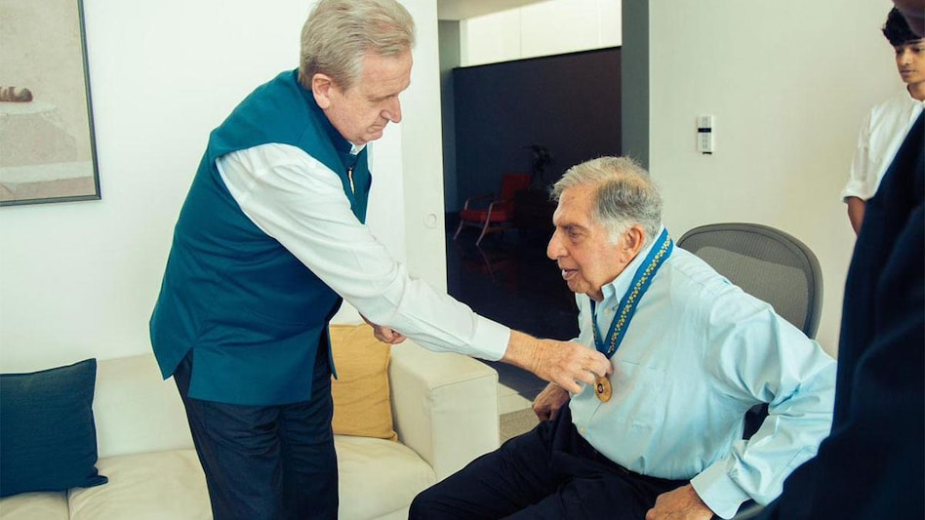

## Personal life and death

Tata never married and had no children. In 2011, he stated, "I came close to getting married four times and each time I backed off in fear or for one reason or another."

Tata was admitted to [Breach Candy Hospital](https://en.wikipedia.org/wiki/Breach_Candy_Hospital) in critical condition and was under intensive care. He died there at 23:30 [IST](https://en.wikipedia.org/wiki/Indian_Standard_Time) on 9 October 2024, at the age of 86 due to age-related issues. Following his death, the [Government of Maharashtra](https://en.wikipedia.org/wiki/Government_of_Maharashtra) and the [Government of Jharkhand](https://en.wikipedia.org/wiki/Government_of_Jharkhand) announced a day of mourning.

On 10 October, Tata was given a [state funeral](https://en.wikipedia.org/wiki/State_funeral).[[81]](https://en.wikipedia.org/wiki/Ratan_Tata#cite_note-statefuneral-82) His last rites were conducted at the parsi crematorium at [Worli](https://en.wikipedia.org/wiki/Worli). He was accorded with military and 21-gun salute during his final rites. Mumbai Police delivered a ceremonial guard of honour and his body was wrapped in the Indian flag.

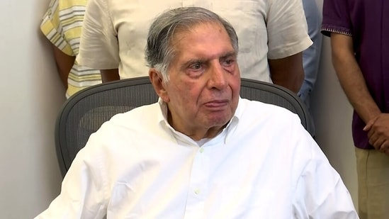

**G.JAGRUTHI**

**324103210063**

**CSE 2**